Fakultät für Ostasienwissenschaften

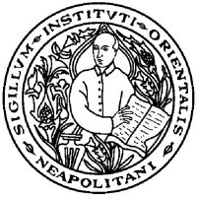
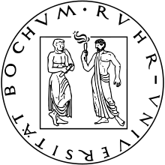
Erasmus guest lectures

Prof. Dr. Donatella Guida

Università degli studi di Napoli “L'Orientale”

Tuesday, October 22, 2013, 14-16h [GB 8/36]

“The other half of the sky: Biography as a genre, with reading of excerpts from Empress Ma’s and Empress Xu’s biographies”

In seminar “Jin Ping Mei” (given by Dr. Rüdiger Breuer), 14-16h.
Open for 3rd year BA students and 1st year MA students (Sinology)

Tuesday, October 22, 2013, 16-18h [GABF 04/409]

“Southeast Asia as seen in Chinese texts, and the relevant sources in geographical and other collectanea”

In seminar “Explorations: ‘Suwenxue congkan‘ and other collectanea (Congshu)” (given by Dr. Christine Moll-Murata and Dr. Rüdiger Breuer)
Open for 1st and 2nd year MA students (Sinology)

Wednesday, October 23, 14-16h [HGB 40]

“The history of Sinology at the Istituto Orientale, Naples:
Matteo Ripa, the Catholic mission and its founding function for academic studies in Mediterranean and European explorations of China”

In seminar “Introduction to Sinology/Einführung in die Sinologie” (given by Prof. Dr. Heiner Roetz and Dr. Christine Moll-Murata)
Open for all students and members of the Faculty of East Asian Studies

